VOICE LESSON: PASSAGGIO PEDAGOGY
COMMON MISCONCEPTION:
Singers often make the mistake of thinking that the male and female voice are worlds apart from each other. The truth is, scientifically, the same machine that creates your voice is in both genders.
Both men and women have a similar structure to the placements of their voice. In modern times we call this “Head voice, Middle voice, and Chest voice” referring to what resonators are focused. In older times of Opera Pedagogy, they referred to these placements as the familiar terms of “Soprano, Mezzo, Contralto” or for men “Tenor, Baritone, Bass”
Now we use those terms to define what type of singer we are.
The truth is that you are all three in one, and the more you work to solidify your voice as one instrument, the more you will discover that you cannot be defined as just a “soprano” or just a “tenor”. Really your voice is all of the above.
VOCAL PASSAGGIOS
A “PASSAGGIO” is series of semi-tones through which your voice is changing placements. This area exists in between the three placements for men and women. Passaggio literally means a “passage” phase of your voice.
It’s EXTREMELY IMPORTANT to train these passages of the voice, they are the main villain of cracks and breaks in the voice because of how sensitive the area is. With correct usage of breath and isolation of resonators, we can smooth it out to be butter.
The following image is an example of how the placements look in the body with relation to pitches that we are singing.
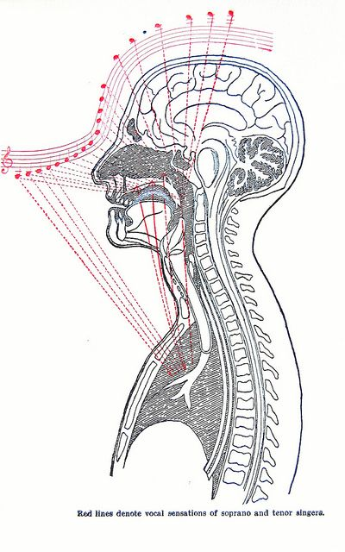
LOW PASSAGIO WARMUP
- Lowest area of the voice, focus on oval vowels, keeping the larynx lowered and play with the palates. Should be a light sensation with no strain.
- “Oo” vowel scales to passaggio
- Lip trills to passaggio
- “holly” to passaggio
- Interval jumps from lowest area voice to middle area of voice is best way to test passaggio. Using consonants between.
- “zing ah” softly with body rolls
- Grab neck and sing on “eezee”

MIDDLE TO HIGH PASSAGIO WARMUP
- This is perhaps the most important area to work on for both male and female voice. As we sing higher pitches, our body is more and more tempted to fight with muscle to produce the sound.
- The goal is to smooth it out to one voice. Seemingly transitioning.
“MIXING” is a term used for accessing mezzo elements in your soprano range (or baritone to tenor). Takes a lot of training or natural ability to perfect it.
- humming exercise with emphasis on back of neck feeling sound moving up to the top of the head
- “ I want to fly” slowly and very legato, identifying where the passaggio lies.
- Sinus focused “na na na”
- “la la la” from top to middle

